ServoFlapOrnithopter 86-3-2&3 setting manual Ver.2　　17/Oct./2022

New Servo Flap System by K.Kakuta

1 Bilateral Servo Flap between Max high point and Max low point

- change max flap point (throttle stick) and change Flapping frequency(5ch)

3 Change center of Flapping angle Horizontal (Ch1 aileron stick) and Vertical (Ch2 elevator stick)

4 Change flapping amplitude on each Servo (Ch4 rudder stick)

Increase flap amplitude of one servo and decrease flap amplitude of another servo

Setting : Set elevator and rudder and aileron stick Center-- 1500microsesond

Set 5Ch at any Volume or Slider or other switch

Set throttle stick at low max --1000 microsecond

5 wiring

1. PPM Receiver—

RX PPM signal input to D2 pin

Servo right --D5 pin

Servo left --D6 pin

5V – from VCC pin of Arduino board

2)Arduino Pro mini board

Ground -GND pin

6V -from DC converter (output 6V) to Raw pin

Need new well act 1cell 70-120mAh over 25C Lipo battery

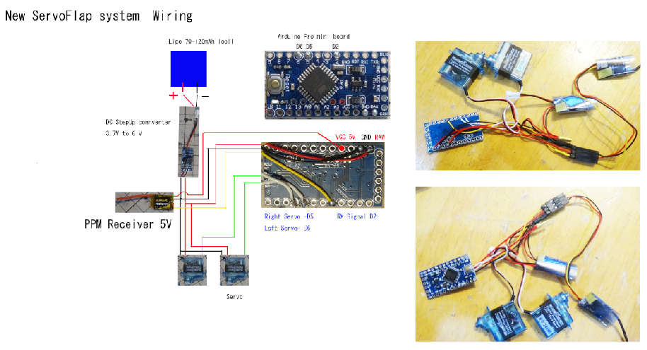

3) Transmitter

Setting of Transmitter

1ch Aileron

2ch Elevator

3ch Throttle

4ch Rudder

5ch change flap cycle time

Scale(endpoint) of Rudder4ch set about 70％（End point -70% and 70％）

If this value is too high, the wings on the other side will also flap greatly.

Throttle 3ch set End point Max 70-150 Min -70-(-150)

This value depends on the receiver

Adjusted so that flapping stops at the lowest position

and becomes the largest flapping at the highest position

6. Arduino code is here: <http://kakutaclinic.life.coocan.jp/SFOsys2S.html>

New Servo Flap System by K.Kakuta

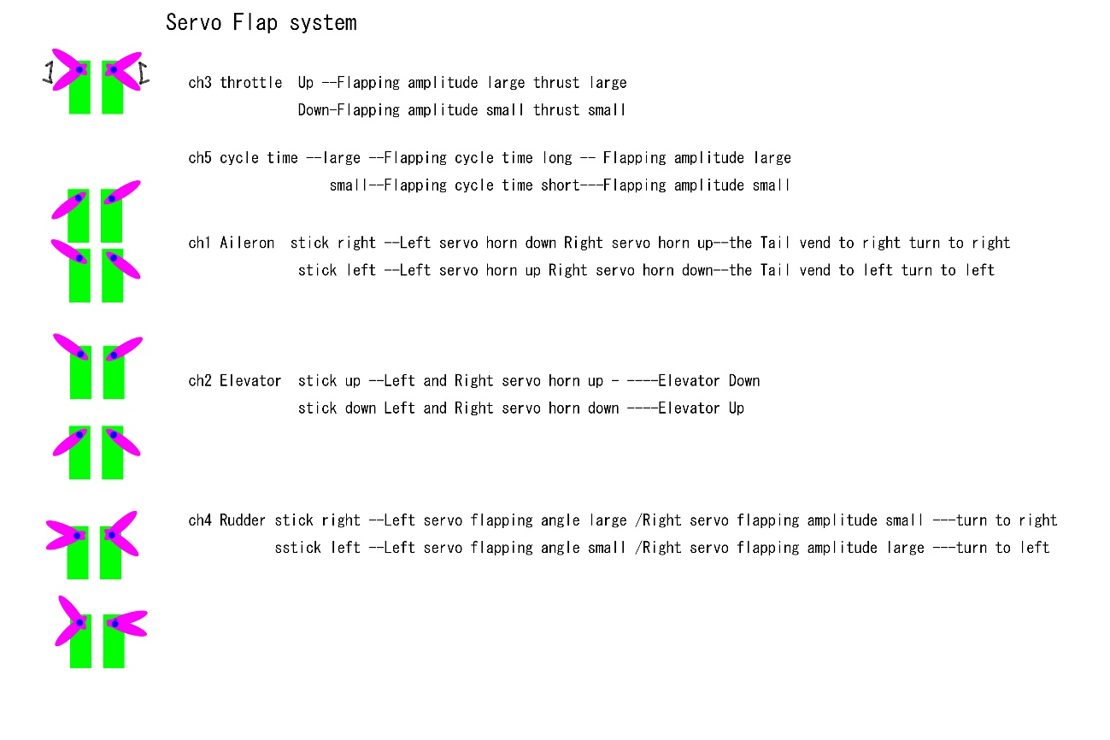

Please look Video of Youtube ---

ServoFlapOrnithopterAmericanKestrel86-3-2＆3 : Servo motion Test

<https://www.youtube.com/watch?v=6pvaHyCRNxU>

ServoFlapOrnithopter86-3-1&2＆3 : Dance of Three SFO86-3 on “One” by Peanuts Jam

<https://www.youtube.com/watch?v=hJ_FGvZynGw>

SFO86-3-2 1st Test Flight

ServoFlapOrnithopterKestrel86-3-2 28g:First Flight Test

<https://www.youtube.com/watch?v=Twz4DYKwONE>

SFO86-3-2 2nd Test Flight

ServoFlapOrnithopterKestrel86-3-2 28g: 2nd Flight Test with slim wing Good Flight and Gliding

<https://www.youtube.com/watch?v=dAebtDR1Rjs>

SFO86-3-3 1st Test Flight

ServoFlapOrnithopterAmericanKestrel86-3-3 28g:First Flight Test Good Flight

<https://www.youtube.com/watch?v=vfHmHvgCPDU>

SFO86-3-3 2nd Test Flight

ServoFlapOrnithopterAmericanKestrel86-3-3 28g:2nd Flight Test Good Flight

<https://www.youtube.com/watch?v=18_kauT8rg8>

My setting  
Lipo: 70-120mAh1cell Lipo battery  
Servo: BLUEARROW AF D43S-6.0-MG Micro Metal Gear Digital Servo

<https://www.aliexpress.com/item/33033558575.html?spm=a2g0s.9042311.0.0.43364c4d6lqbJw>

<https://jp.banggood.com/BLUEARROW-AF-D43S-6_0-MG-Micro-Metal-Gear-Digital-Servo-For-XK-K130-RC-Helicopter-p-1509395.html?rmmds=myorder&cur_warehouse=CN>

# Servo Horn：Bluearraow Metal V950 D05023MG / K130 D03018MG Servo Swing Arm Parts For Wltoys XK K130 V950 6CH RC Helicopter

<https://www.aliexpress.com/item/4001120547325.html?spm=a2g0s.9042311.0.0.43364c4d6lqbJw>

Arduino Pro mini board  
DC stepup converter from 1cell Lipo 3.7V to 6V output

----7W mini Step-up Converter 3.7V to 6V

<https://www.aliexpress.com/item/1005001419105670.html?spm=a2g0s.9042311.0.0.27424c4dTyeLKp>

<https://jp.banggood.com/7W-Mini-DC-DC-Boost-Step-Up-Converter-2_6-5_5V-to-5V-6V-9V-12V-Voltage-Regulator-Module-p-1626160.html?rmmds=myorder&cur_warehouse=CN&ID=519957>

PPM receiver: under 2g (Smaller RX is better)

OrangeRx R616XN DSM2 / DSMX 6CH CPPM

<https://hobbyking.com/jp_jp/orangerx-r616xn-dsm2-dsmx-compatible-6ch-cppm-nano-receiver-with-failsafe.html>

On this RX

Transmitter Setting 　Endpoint

Aileron +-100% Elevator +-100% Throttle +-123%

Rudder +-70%(Smaller is better)

# FS-RX2A pro v1 2.4g 10ch ibus ppm afhds 2a flysky

<https://ja.aliexpress.com/item/1005002954612657.html?spm=a2g0o.productlist.0.0.23443335KFji3j&algo_pvid=4d1462c8-953f-4815-bb81-8dcc7f45ab2b&algo_exp_id=4d1462c8-953f-4815-bb81-8dcc7f45ab2b-9&pdp_ext_f=%7B%22sku_id%22%3A%2212000022943448015%22%7D&pdp_pi=-1%3B1598.0%3B-1%3B-1%40salePrice%3BJPY%3Bsearch-mainSearch>

On this RX

Transmitter Setting 　 Endpoint

Aileron +-100% Elevator +-100% Throttle +75 -98%

Rudder +-70%(Smaller is better)

**If abnormal behavior occurs at maximum or minimum output, decrease EndPoint until the abnormal behavior disappears and it works well.**

Arduino code is here:

<http://kakutaclinic.life.coocan.jp/SFOsys2S.html>

Setting RX and Lipo set CG

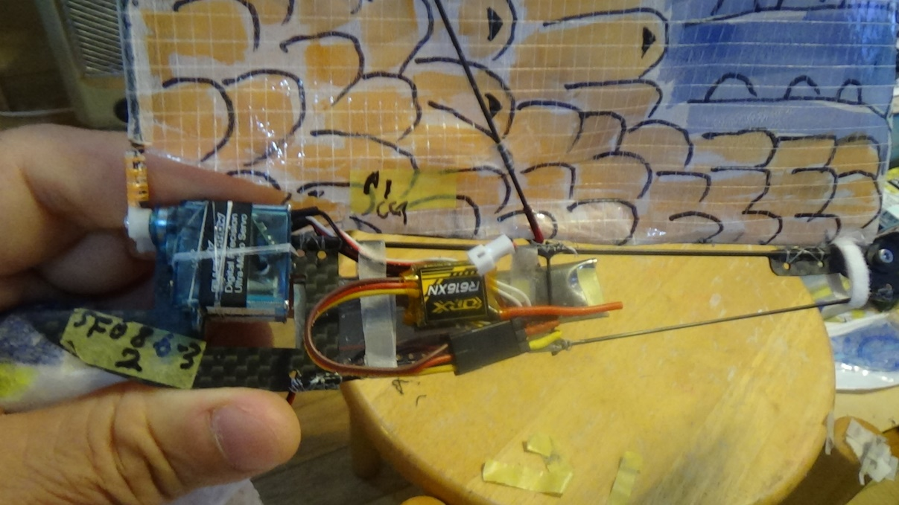

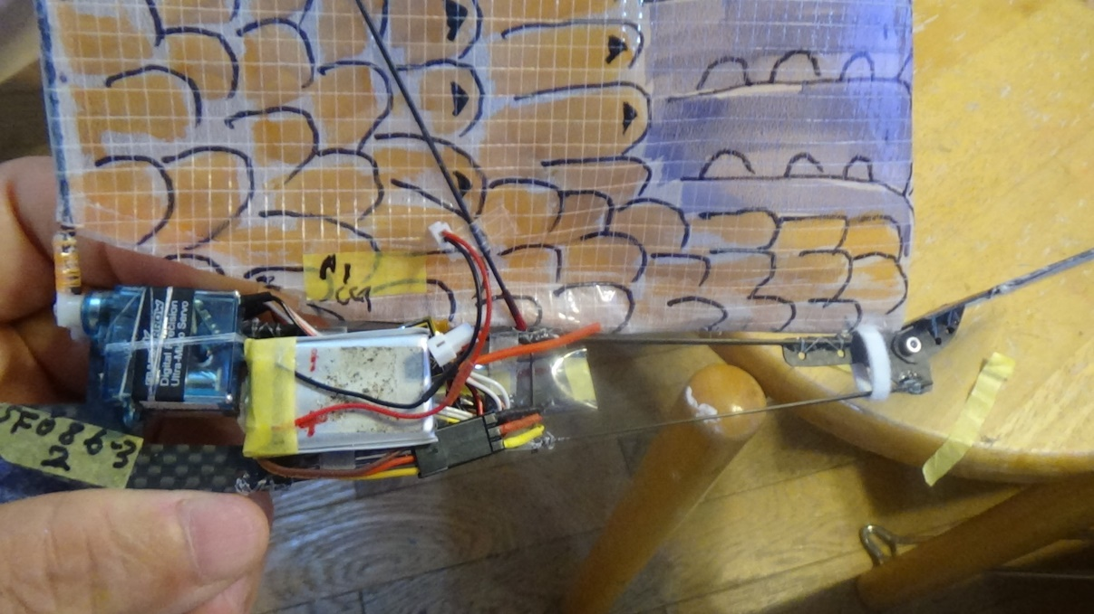

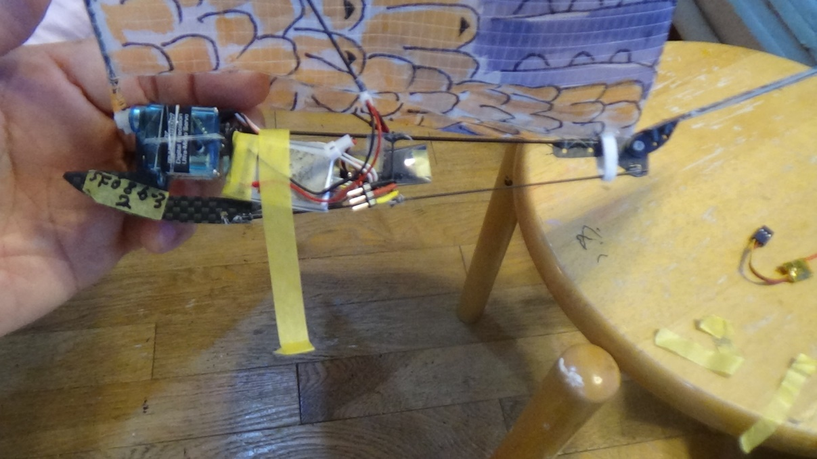

**Flight**

1) Set the throttle lever to the bottom

2) Connect Lipo battery then the wings of SFO86-2&3 spread out

3) Adjust the angle of the tail and/or CG position for gliding

This is adjusted according to flight conditions.

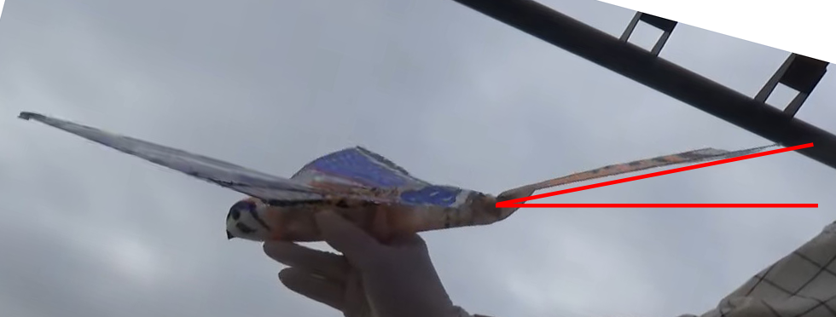

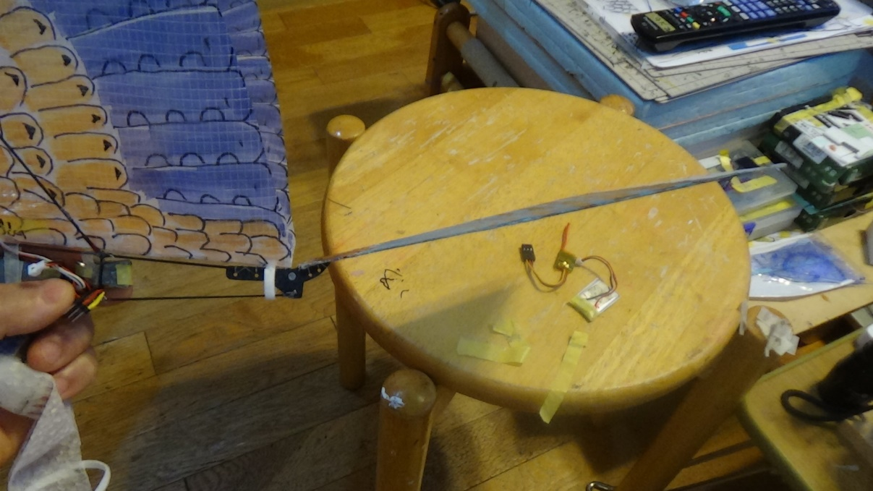

SFO86-3-2 Tail angle

And

Set the dihedral angle.

This is adjusted according to flight conditions.

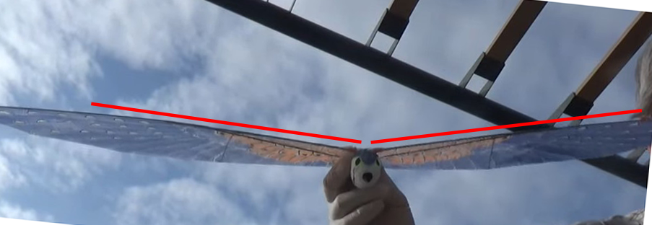

4) Adjust the flapping frequency with Ch5（volume switch or slider switch）

　　　You need to watch the flight video of SFO86-2&3

and find the right flapping frequency.

SFO86-3-2

<https://www.youtube.com/watch?v=dAebtDR1Rjs>

SFO86-3-3

<https://www.youtube.com/watch?v=18_kauT8rg8>

5)Adjust Aileron (Ch1) subtrim of the transmitter so that SFO86-2&3 flies straight when gliding.

Basically, you can fly smoothly by changing direction with Rudder rather than changing direction with Aileron.

When Rudder is not effective, reduce the number of flapping during flight (reduce the throttle) to improve to turn.

Flap wings ----Go Flight!!

Repeat the adjustment until it flies well.

If you can get the SFO86-3 on an updraft, you can make the SFO86-3 to fly higher.

-------------------------------------------

Lipo 　need over 25C

for example.

G5 1S 120mAh LiPo 25C (4.2V)

<https://hyperion-world.com/en/p2743080-hp-g550-0120s1>

# G5 1S 70mAh LiPo 25C (4.2V) w/ Ultra Micro Connector

<https://hyperion-world.com/en/p2743034-hp-g550-0070s1um>

RX – Need PPM output , need less than 2g

# for example

# XR502 2.4G SBUS PPM RSSI Dual Antenna Micro Receiver for DSM X/2 SFHSS Frsky-D8/D16 AFHDS-2A Radio Transmitters RC FPV Drone

<https://www.aliexpress.com/item/1005001848582101.html?gatewayAdapt=4itemAdapt>

# FrSky R-XSR Ultra SBUS/CPPM D16 16CH Mini Redundancy Receiver 1.5g

<https://www.aliexpress.com/item/4001200707741.html?spm=a2g0o.order_list.0.0.21ef1802X2dOTN>

-----------------------------------------------------

* Repair of Carbon rod

